Customer Abandonment and Price Sensitivity Analysis
A Data Driven Case Study and Excel Dashboard
Prepared by: David Asikpo
Role: Data Analyst
Tool Used: Microsoft Excel
Date: January 2026

1. INTRODUCTION
Cart abandonment is a persistent challenge in this e-commerce data, often signaling friction between customer expectations and the purchasing experience. While customers may show strong intent through browsing and product discovery, many fail to complete transactions due to cost related concerns such as pricing and shipping fees.
This report analyzes customer abandonment behavior using transactional and behavioral data to identify key drivers of abandonment, uncover vulnerable customer segments, and propose practical, data driven solutions. To support decision making, an interactive Excel dashboard was developed to visualize insights, enable segmentation analysis, and track performance.

2. EXECUTIVE SUMMARY
Problem Statement
The e-commerce platform experiences significant cart abandonment driven largely by price sensitivity and cost related friction which majority of customers being the “Gen Z Females” . These abandonments vary across product categories and shopping behaviors, resulting in lost revenue despite strong customer engagement.
Objective
To identify the primary causes of cart abandonment, determine which customer segments and categories are most affected, and design a solution oriented Excel dashboard that supports actionable decision making.
Key Findings
- Out of 602 total customers, 42% of abandonments (255 customers) are driven by price sensitivity.
- Beauty and Personal Care is the most affected category, accounting for 41% of total abandonments with Gen Z Females being a huge contributor
- Price competition impacts all search methods, including keyword search, category browsing, and filters.

3. DATA STORY AND KEY INSIGHTS
Insight 1: Price Sensitivity Is the Primary Driver of Abandonment and Less Frequent Purchase by Customers
Analysis shows that “Found a better price elsewhere” is the dominant abandonment reason across all major categories.
- Beauty and Personal Care records the highest volume of price driven abandonment.
- Similar trends are visible in Clothing and Fashion and Groceries, indicating widespread comparison shopping behavior.
Interpretation
Customers are highly price aware and willing to abandon carts even after engaging with products. Competitive pricing and perceived value outweigh product discovery efforts. Below finding better price elsewhere is the segment in yellow.
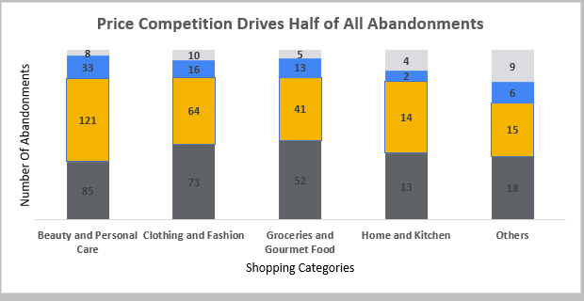

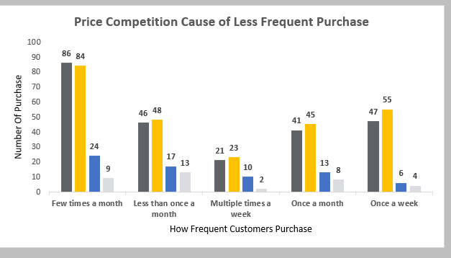

Insight 2: Shipping Costs Create Category Specific Friction
High shipping costs emerge as the second most significant abandonment driver, but with notable variation by category.
- Clothing and Fashion shows higher abandonment due to shipping costs.
- Beauty and Personal Care customers are more tolerant of shipping costs but less tolerant of price differences.
Interpretation
A uniform shipping strategy does not align with customer expectations across categories. Cost sensitivity differs depending on product type and purchase intent.

Insight 3: Price Competition Affects All Search and Discovery Methods
Dashboard analysis reveals that:
- Keyword search, category browsing, and filtered searches all experience substantial price driven abandonment.
- Keyword search shows particularly high abandonment volume, suggesting that strong intent alone does not guarantee conversion.
Interpretation
Improving discovery and personalization alone will not reduce abandonment unless price competitiveness and cost transparency are addressed.

4. Customer Demographic Behavior
Using demographic and behavioral filters within the dashboard, the most vulnerable customers share the following characteristics:
- Frequent browsing behavior using keyword and category search
- Primary purchases in Beauty and Personal Care and Clothing and Fashion
- High sensitivity to external price comparisons and unexpected shipping costs
These customers are engaged but value conscious, representing recoverable revenue rather than disengaged users.

5. STRATEGIC RECOMMENDATIONS
Immediate Actions
- Price Competitiveness Monitoring
Monitor competitor pricing for top selling SKUs in Beauty and Personal Care.
- Shipping Cost Transparency
Surface shipping costs earlier in the checkout journey, especially for Clothing and Fashion.
- Targeted Cart Recovery Campaigns
Apply category specific incentives such as discounts for Beauty products and free shipping thresholds for Clothing purchases.
Medium Term Improvements
- Category Based Pricing Strategy
Align promotions with category level price sensitivity instead of using uniform discounts.
- Value Focused Messaging
Emphasize overall value, bundles, and savings rather than generic promotions.
- Dashboard Driven Performance Tracking
Use the Excel dashboard to monitor changes in abandonment behavior after interventions.

6. THE DASHBOARD AS A DECISION SUPPORT TOOL
The Excel dashboard translates analytical findings into an interactive management tool by enabling:
- Filtering by age group, gender, and abandonment Factors
- Category level comparison of price sensitivity
- Visibility into abandonment by search and discovery method
- Ongoing monitoring of key metrics after strategic changes
The dashboard was designed to demonstrate practical Excel skills, including PivotTables, slicers, calculated metrics, and visual storytelling.

7. CONCLUSION
Cart abandonment in this analysis is driven primarily by perceived value rather than lack of interest or poor discovery. Customers reach products but disengage when price and shipping costs do not meet expectations.
By addressing price competitiveness and improving cost transparency, the business can significantly reduce abandonment and recover lost revenue. The accompanying Excel dashboard ensures that these insights remain visible, actionable, and measurable over time.

End of Report
Prepared by: David Asikpo

